www.discipleshipcourse.org

Leadership Manual

Michael Dörnbrack

Table of Content

1. The Discipleship Commission 3
2. The Principles of Discipleship 6
3. The Disciple-Making-Strategy of Jesus 9
4. The Principle of Multiplication 11
5. Small Groups 13
6. Discovery Bible Study 16
7. Bible Study in Discipleship Groups 20
8. What does a Discipleship Group meeting look like? 22
9. Mission Through Discipleship Groups 23

- The Discipleship Commission
For three and a half year Jesus had trained his disciples for that commission. Before ascending to heaven, he said:
“All authority has been given to Me in heaven and on earth. Go therefore and make disciples of all the nations, baptizing them in the name of the Father and of the Son and of the Holy Spirit, teaching them to observe all things that I have commanded you; and lo, I am with you always, even to the end of the age.” Amen.” (Matthew 28:18-20)
There are certain things is this passage, that we must notice and remember.
- This commission is embedded in two promises of Jesus: He is given all power and He is with us always. This commission can only be fulfilled in the power of Jesus. Fulfilling the Great Commission is cooperation with God who is more active reaching out to the lost and helping believers to grow than we can ever be.
- Jesus says: Go! We are not to wait for people to come to us. We must search for and go after them. We must be proactive.
- Jesus says that we should teach people to obey everything he has commanded. Discipleship is not just about conveying information but about loving obedience. Jesus commanded obedience-based discipleship.
- The centre of the commission is the command to make disciples. In the original Greek it is the only imperative. Literally is says: “Going, make disciples …, teaching them.” Therefore, it is best to call it the discipleship commission. To understand how far-reaching this commission is, we need a clear understanding about how Jesus defined a disciple. First and foremost, a disciple is someone who lives in a saving and growing relationship with Christ. He abides in God´s word, lives healthy loving relationship with other disciples and brings fruit.
- When Jesus says: “teaching them to observe all things that I have commanded you” that implies this very commission, too. The disciples must have said to themselves: "Look, we are supposed to do with others what He did with us. And teach them to do the same with others." The discipleship commission implies multiplication. Every believer should be a disciple and a disciple maker.
Discipleship is growth; it a process that consists of five different stages: conversion, spiritual growth, witnessing, leader and training.

Conversion
Growth
Witnessing
Leading
Training

These five stages are not strictly chronological. They are interdependent. Someone who is converted does not have to wait until he has grown spiritually before he can share Jesus and give Bible studies. On the contrary, he will grow by witnessing to others.
This model teaches us that discipleship is more than conversion. Always keep that in mind when you lead people to Jesus. You must be intentional to disciple them. The goal is:
- to help our friends to grow in their relationship with Jesus,
- teach them spiritual disciplines like bible study and prayer
- help them to experience to power of the Holy Spirit in their lives
- equip them to share the Gospel with the people in their personal networks
- train them be train others to be disciples and disciple-makers.
The model of the five stages of discipleship helps us to evaluate the spiritual health of a church. Think about it! How can we measure the spiritual health of a church? Is it by the number of people on the list? Certainly not. We all know that is possible to be a church member without really knowing Jesus. And there are many people in our books who do not come to church anymore. Or is it by the number of people attending church? This is a little better, but again, we have members attending church without having assurance of salvation. So how can we measure the spiritual health of a church? Look at this statement by Ellen G. White:
“When Christ ascended, He left the church and all its interests as a sacred trust to His followers. And the work of the church is not to be left to the minister alone, or to a few leading men. Every member should feel that he has entered into a solemn covenant with the Lord to work for the best interests of His cause at all times and under all circumstances. Each should have some part to act, some burden to bear. If all church-members felt an individual responsibility, greater advancement would be made in spiritual things. The solemn burden of responsibility resting upon them would lead them to seek God often for strength and grace.
The real character of the church is measured, not by the high profession she makes, not by the names enrolled on her books, but by what she is actually doing for the Master, by the number of her persevering, faithful workers. Personal, unselfish effort will accomplish more for the cause of Christ than can be wrought by sermons or creeds.
Let ministers teach church-members that in order to grow in spirituality, they must carry the burden that the Lord has laid upon them,--the burden of leading souls into the truth. Those who are not fulfilling their responsibility should be visited, prayed with, labored for. Do not lead the people to depend upon you as ministers; teach them rather that they are to use their talents in giving the truth to those around them. In thus working they will have the co-operation of heavenly angels, and will obtain an experience that will increase their faith, and give them a strong hold on God.” (Gospel Workers, p. 200)
The spiritual health of a church can only be measured by the number of those you are actively working for Jesus. That is by the number of disciples.
Now take an honest look at your local church. Look at the membership in your field. How many of the members …
- have experienced salvation personally
- study a Bible daily
- have a vibrant prayer life
- are filled with the Holy spirit
- are sharing Jesus in their everyday life
- and disciple others to do the same?
In most cases, it is only a very small percentage. But think about what could happen in your church if you can train 10, 20 or 30 people to share the Gospel, give Bible studies, lead small groups and disciple others! Think about the impact when you do not build on the principle of addition but on the principle of multiplication because you train people to be training others.

- The Principles of Discipleship
Jesus not only told them what they were supposed to do! He had modelled himself how to do it. You see, the method of Jesus to make disciples is unsurpassed. In making disciples we must follow Jesus' example. That brings us to the principles of discipleship. These principles are not simply methods; rather they are foundational values that constitute the DNA of the church.

God´s word
Obe-dience
Calling
Fellow-ship
Prayer
Mission
Training

Christ as the centre
The heart in the centre stands for a saving relationship with Jesus, for the message of justification of faith. This is the centre without which everything else would be useless. It means to be in Christ and have Christ in us. Christ in us is the same as being filled with the Holy Spirit. Our goal is to lead people to a relationship with Jesus. Everything else like Bible knowledge and lifestyle has only value as it grows out of this relationship.

God´s word
Jesus made the word of God central in his teaching. And he taught his disciple to follow this example. He helped them to understand the Word for themselves and not be dependent on another teacher to understand it.

Obedience
Jesus told his disciples “If you love me, keep my commandments.” He made it very clear that he expected his followers to obey. It is clear that we are saved by grace alone, but obedience is the only way of experience a change in our lives.

Calling
The next symbol stands for urgency and a consciousness of having been called by God to proclaim a message that everyone must hear. John the Baptist, Jesus himself and the early Christians knew that their mission was a fulfilment of prophecy. This understanding of their prophetic calling gave them a sense of urgency. As Seventh-day Adventists we have been entrusted with a message that must be proclaimed in the whole world before Jesus will come back. We need a clear understanding of our prophetic calling and message.

Fellowship
Jesus started a small group of disciples and taught them to do the same. The book of Acts testifies that the church consisted of small groups meeting in the homes. We also need small groups that are flexible and easy to lead.

Prayer
Jesus himself spent a lot of time in prayer and he taught his disciples to pray. There is no discipleship without a lot of prayer.

Mission
Jesus spent a lot of time helping people in their needs. He healed them, visited them, and ministered to their needs. But he always had the goal to reach them for his kingdom. Therefore, he used every opportunity to proclaim the gospel. Helping people and sharing the Gospel must never be separated.

Training
Jesus intentionally trained his disciples to serve people, share the Gospel and make disciples. We must have the clear focus to train as many members as are willing to learn to do the same. Whenever someone has decided to follow Jesus, we should immediately train him to share his faith with others.

- The Disciple-Making-Strategy of Jesus
Take time to study Matthew 9:35-38; 10:1-15 and Luke 10:1-12 and ask the questions: What did Jesus do? What should the disciple do? Write down your answers in this table:
What did Jesus do? | What should the disciples do?
What Jesus did:
- went to lost people
- taught and preached the Gospel of the kingdom
- healed
- had compassion for lost people
- saw a great harvest
- prayed for laborers (see Luke 6:12)
- called his disciples and focused on them
- empowered them and sent them out to preach and heal

What the disciples should do:
- see a great harvest and have compassion for the lost
- pray for laborers
- go to the lost people
- preach the Gospel of the kingdom of God
- heal
- let people in the harvest supply the resources for the ministry
- find people who are open and focus on them
- leave and move on when they don´t find open people
Jesus saw the huge need and knew that he could never reach so many people themselves. That´s why he called his disciples and told them to do the very same thing that he did. They should see the harvest and join Jesus in praying for more laborers for the harvest. But just like Jesus who not only prayed for laborers but laboured for people himself and empowered his disciples to be laborers as well, the disciples should do the same.

Praying for laborers means:
- making yourself the first answer to that prayer and become a labourer
- actively looking for and empowering new laborers
- and tell them to do the same with others
Jesus commanded his disciples to always look for people and houses who are worthy. In Luke they are called “sons of peace”. In literature they are most often called “persons of peace.” They should identify them, go into their houses and preach the gospel. If they found such a house, they should not continue to go from house to house but focus on that family. They should train them, because the work should continue to spread from this one family to other families when the disciples have moved on. They should carry on the work und not be dependent on the apostles. They were the new laborers the disciples prayed for and should not do with others what the disciples had done with them.
We have seen that Jesus had a strategy as he pursued discipleship: He reached the lost and trained the saved.
In his training he also followed a pattern.
- He trained and sent out as soon as someone was saved. (Mark 1:16,17; 5:19,20; John 4:28-30)
- He trained many, but then focused on few. (Matthew 10:1; Luke 10:1-2)
In our ministry we need the same approach. We should always strive to reach out to the lost and at the same time train the saved to reach out to the lost as well. So again, the strategy is:
- reaching the lost and training the saved
- training and sending out as soon as possible
- training many and focusing on few
Let me stress this point: As soon as someone has found Jesus, he should be trained to reach out to others. There is no need to wait until someone has been baptized. Even before someone has given his life to Jesus, he can be taught, how to share, what he has learned. So, from the very beginning, sharing should be part of the DNA.
Please look at the following statements by Ellen White and notice how she described how Jesus trained his disciples:
“The apostles were members of the family of Jesus, and they had accompanied Him as He traveled on foot through Galilee. They had shared with Him the toils and hardships that overtook them. They had listened to His discourses, they had walked and talked with the Son of God, and from His daily instruction they had learned how to work for the elevation of humanity. As Jesus ministered to the vast multitudes that gathered about Him, His disciples were in attendance, eager to do His bidding and to lighten His labor. They assisted in arranging the people, bringing the afflicted ones to the Savior, and promoting the comfort of all. They watched for interested hearers, explained the Scriptures to them, and in various ways worked for their spiritual benefit. They taught what they had learned of Jesus, and were every day obtaining a rich experience. But they needed also an experience in laboring alone. They were still in need of much instruction, great patience and tenderness. Now, while He was personally with them, to point out their errors, and counsel and correct them, the Savior sent them forth as His representatives.” (The Desire of Ages, p. 349)
“For three years and a half the disciples were under the instruction of the greatest Teacher the world has ever known. By personal contact and association, Christ trained them for His service. Day by day they walked and talked with Him, hearing His words of cheer to the weary and heavy-laden, and seeing the manifestation of His power in behalf of the sick and the afflicted. Sometimes He taught them, sitting among them on the mountainside; sometimes beside the sea or walking by the way, He revealed the mysteries of the kingdom of God. Wherever hearts were open to receive the diving message, He unfolded the truths of the way of salvation. He did not command the disciples to do this ort hat, but said ’Follow Me.’ On His journeys through country and cities, He took them with Him, that they might see how He taught the people. They traveled with Him from place to place. They shared His frugal fare, and like Him were sometimes hungry and often weary. On crowded streets, by the lakeside, in the lonely desert, they were with Him. They saw Him in every phase of life.“ (Acts of the Apostles, p. 17-18.)
The strategy of Jesus is the key for multiplication. As soon as someone has opened his heart for Jesus, he should be trained to share his faith. We should train as many people as possible and then focus on the ones who put into practice what they have learned. Typically, only 10-15% of those you train will put into practice what they have learned. That is simply the reality. We must focus on the obedient ones and give them more training and coaching. The goal is always that they will do the same for others.
Ellen White strongly emphasized the need of training church members:
“The monotony of our service for God needs to be broken up. Every church member should be engaged in some line of service for the Master. Some cannot do so much as others, but everyone should do his utmost to roll back the tide of disease and distress that is sweeping over our world. Many would be willing to work if they were taught how to begin. They need to be instructed and encouraged.
Every church should be a training school for Christian workers. Its members should be taught how to give Bible readings, how to conduct and teach Sabbath-school classes, how best to help the poor and to care for the sick, how to work for the unconverted. There should be schools of health, cooking schools, and classes in various lines of Christian help work. There should not only be teaching, but actual work under experienced instructors. Let the teachers lead the way in working among the people, and others, uniting with them, will learn from their example. One example is worth more than many precepts.” (The Ministry of Healing, p. 76)
“That which is needed now for the upbuilding of our churches is the nice work of wise laborers to discern and develop talent in the church,--talent that can be educated for the Master's use. There should be a well organized plan for the employment of workers to go into all our churches, large and small, to instruct the members how to labor for the upbuilding of the church, and also for unbelievers. It is training, education, that is needed. Those who labor in visiting the churches should give the brethren and sisters instruction in practical methods of doing missionary work. (Christian Service, p. 58)
“It is evident that all the sermons that have been preached have not developed a large class of self-denying workers. This subject is to be considered as involving the most serious results. Our future for eternity is at stake. The churches are withering up because they have failed to use their talents in diffusing light. Careful instruction should be given which will be as lessons from the Master, that all may put their light to practical use. (Christian Service, p. 58)

- The Principle of Multiplication
If we want to see a multiplication, we must apply the following principles for multiplication.

Small groups
Flexibility
Simple methods
Vision/Leadership
Evangelism as priority
Accountability
Empowering Leaders

Small groups (Five Fingers)
We have five fingers on each hand, not twenty. We need small groups that can easily be led and multiplied.

Flexibility
As our fingers are flexible, we have to be flexible with our methods and be willing to adapt. We cannot compromise the biblical message and the principles of discipleship but in the use of our methods we have to be flexible.

Simple Methods (Thumb up: I can do it!)
We need simple methods, a clear path and easy steps. Only then other will follow our example. At every step, we must ask: Is what I am doing reproducible? If our methods are so difficult that only a few experts can use them, we will not see a multiplication of disciples.

Vision and Leadership (Index finger: shows the way)
We need a clear understanding of God´s plan to reach the world through a multiplication of disciples. It takes leadership to keep this vision continually before us.

Evangelism (Middle finger: is the longest)
Multiplication can only happen when the sharing the Gospel with the lost is paramount. The question: “How many will hear the Gospel this week through us this week?” should drive us to share it continually!

Accountability (Ring finger)
As we commit to be obedient to the discipleship commission, we have to encourage each other to follow through on our commitment. We must hold each other accountable for what we have agreed to do.

Empowering leaders (little finger: The little ones must grow.)
We need an attitude to constantly empower leaders to grow and accept more responsibility. A multiplication of disciples always goes along with a multiplication of leaders.

- Small Groups
When Jesus started his ministry, he called his disciples and formed a small group. The early Christians followed this example. When you read the New Testament, you see that the early church had s small group structure. They met in the homes of the believers.
The house churches of the early Christians had many advantages:
- The early Christians lived in close fellowship, which made it easy to constantly invite friends.
- This practical Christian fellowship was an environment which made it easy for their friends to make a decision for Jesus and His church.
- The house churches were the ideal place to grow in faith and to learn how to share the gospel.
- Each person could contribute with their talents and skills.
- The believers knew each other so well that they could help and support one another.
- The large number of home churches made it easy to take in new believers.
- When a church got too big it was simply divided. Thus, new leaders were always needed, who had been trained in the home churches.
- In times of persecution the church was very flexible. If it became impossible to meet in one place as a church, then they simply met in other homes.
It should not surprise us that Ellen White stressed to importance of small groups, too.
“Why do not believers feel a deeper, more earnest concern for those who are out of Christ? Why do not two or three meet together and plead with God for the salvation of some special one, and then for still another? In our churches let companies be formed for service. Let different ones unite in labor as fishers of men. Let them seek to gather souls from the corruption of the world into the saving purity of Christ’s love.
The formation of small companies as a basis of Christian effort has been presented to me by One who cannot err. If there is a large number in the church, let the members be formed into small companies, to work not only for the church members, but for unbelievers. If in one place there are only two or three who know the truth, let them form themselves into a band of workers. Let them keep their bond of union unbroken, pressing together in love and unity, encouraging one another to advance, each gaining courage and strength from the assistance of the others. Let them reveal Christlike forbearance and patience, speaking no hasty words, using the talent of speech to build one another up in the most holy faith. Let them labor in Christlike love for those outside the fold, forgetting self in their endeavor to help others. As they work and pray in Christ’s name, their numbers will increase; for the Saviour says: “If two of you shall agree on earth as touching anything that they shall ask, it shall be done for them of My Father which is in heaven.” Matthew 18:19.“ (Testimonies to the Church, vol. 7, p. 21)
Small groups have many advantages.
Yesterday we have seen that small groups should be the “basis of Christian effort”. Small groups should be the basis of everything that we do, both in our work inside the church and in our outreach.
Small groups have many advantages:
- they are easy to lead
- it´s easier to train people in small groups
- every member can actively participate
- there is deep fellowship and love
- they are flexible
- they can meet in the home and don´t incur extra costs
- they can easily multiply as they grow
- they can grow into house churches
- they empower many members and give them responsibility and ownership
- the church is present where live takes place
- it is easier and more natural to invite friends to a home than to a church

There are different types of small groups: discipleship groups, care groups, Bible studies, ministry groups, prayer groups and others.

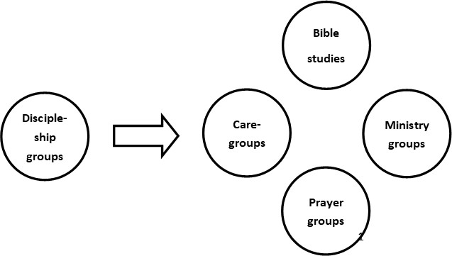

- Discipleship Groups are traing groups for church members that meet for a limited number of weeks or months in order to be spiritually nurtured and trained for personal evangelism and small group leadership.
- Caregroups are open, mission-focussed, fellowship-orientated small groups that are always open for new guests. They create an environment that makes it easy to get to know and experience Jesus and grow in one´s faith. The Bible study is simple and focuses on life application. The meetings usually start with a meal.
- Personal Bible studies are small groups in which the message of the Bible is systematically studied in order to help people get to know the Bible and lead them to baptism. They are usually smalll (2-4 people), take place in the homes of the people and take less than one hour.
- Prayer groups are small groups in which member regularly come together to pray earnestly.
- Ministry groups are teams that meet to address specific needs in the in the church and in the community, e.g. health ministry, pathfinders, social projects, etc.
In this leadership manual we will focus especially on discipleship groups.
When small groups come together, they follow the example of Acts 2:41-47!
“And they continued steadfastly in the apostles’ doctrine and fellowship, in the breaking of bread, and in prayers. Then fear came upon every soul, and many wonders and signs were done through the apostles. Now all who believed were together, and had all things in common, and sold their possessions and goods, and divided them among all, as anyone had need. So continuing daily with one accord in the temple, and breaking bread from house to house, they ate their food with gladness and simplicity of heart, praising God and having favor with all the people. And the Lord added to the church daily those who were being saved.”
In this passage you see the four essential elements of every small group meeting:
- fellowship
- Bible study
- mission and
- prayer
These four elements belong into every type of small groups. The emphasis will vary from type to type but they should be present in every small group.

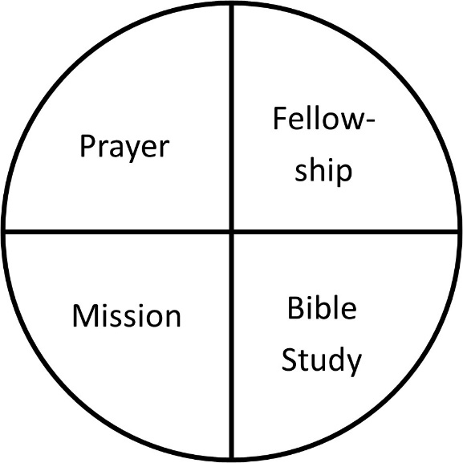

- Discovery Bible Study
We said that, in order to see multiplication, we need methods that are biblical and simple. That applies especially to Bible study and personal evangelism. In this discipleship we, we will focus on the Discovery Bible Study method (DBS).
This is the idea: The best way to study the Bible with our friends is to help them to discover what the Bible says on their own, instead of explaining everything to them. This way the focus and the authority remain on the Bible and not on you as the teacher. That´s why your job in small groups is not to teach the Bible. Instead, your job is to facilitate the discovery process. This method is called Discovery Bible Study or Discovery Bible Reading. On www.discipleshipcours.org we use the expression Discovery Bible Study (DBS) as this is the more common expression. DBS follows eight basic principles:

- The DBS method works well in a one-on-one setting, but it is better to study the Bible in small groups. The participants learn from each other, they encourage each other, and they remember better what they have learned. So whenever possible, study the Bible in small groups.
- In DBS the focus remains on Bible text. We try to observe every detail and want to get our answers from the text.
- Instead of lecturing, the leader simply asks good questions about observations, insights and application to help his friends to discover for themselves what the Bible passage says. There are some questions that you can ask almost about every Bible passage. These questions reflect the heart of the biblical message.
- The stories of the Bible are the best way to discover the message of the Bible and apply them personally, because we see how people experienced God, how God dealt with them and what God is like. We read about people´s victories and failures and can identify with them. These stories encourage us to trust God.
- The Bible not just about information to be learned but about truths to be obey. That´s why it is important to emphasize the practical application and obedience of what we learn from the Bible.
- Tell your friends that every blessing in meant to be shared. Therefore, encourage them to share with others what they have learned from the Bible and experienced with God.
- Encourage your friends to read the Bible in their own quiet time. Give them the bible text for your next meeting in advance so they can already read the story before you meet again. Also share how you are doing your personal quiet time with Jesus. Giving your friends a Bible reading plan is also a great help.
- Always keep in mind that the goal is multiplication. As you lead such a small group, your responsibility is also to train your friends how to learn to read the Bible for themselves and to study the Bible with others in the same way as you study the Bible with them. So as soon as possible let others lead the DBS in your group. This is training on the job and will help your friends to grow into leaders. That works only when your method is biblical, practical, and simple. Only then it can multiply.
Ellen White called this inductive way of studying the Bible “Bible reading”. See how she described the advantages and the impact of this method:
“The plan of holding Bible readings was a heaven-born idea. There are many, both men and women, who can engage in this branch of missionary labor. Workers may thus be developed who will become mighty men of God. By this means the Word of God has been given to thousands; and the workers are brought into personal contact with people of all nations and tongues. The Bible is brought into families, and its sacred truths come home to the conscience. Men are entreated to read, examine, and judge for themselves, and they must abide the responsibility of receiving or rejecting the divine enlightenment. God will not permit this precious work for Him to go unrewarded. He will crown with success every humble effort made in His name.” (Christian Service, p. 141)
Discovery Bible Study is a core method of this discipleship concept. It is used in giving Bible studies, leading small groups and training people for discipleship and leadership.
Using questions has many advantages:
- You don´t give a monolog, but rather give your friends the chance to discover the answers for themselves. In this manner it is much more valuable for your friend.
- By asking good questions you encourage people to think for themselves.
- It creates a real conversation, which helps you to understand the other person and see where they are spiritually.
- You confront them with God’s Word and not with your opinion. They can see for themselves if it is biblical or not. Thereby you are emphasizing the importance of God’s Word. You simply say: “Look for yourself and see what answer God has for your question.” and lead him directly to the source. In this manner God can work much more powerfully.
- The application questions always challenge a person to make a practical application of what was read. They are also decision questions and encourage a person in a natural and open manner to implement practical decisions.
- This method of giving Bible studies is very simple. Many church members could be trained in this method to hold Bible studies. They can do away with the thought that they have to preach an hour-long sermon.
- Since the answers to your questions can be quite different depending on the situation, each Bible study is unique and a special experience.

Now when you think about questions you can ask of a Bible passage, think about the main purpose of the Bible. It is to show us
- what God is like
- what human beings are like
- how a relationship with God looks like and how we can get there
When you ask questions about these things you are at the very heart of the Bible and don´t get caught up in minor details. So, after reading the Bible story, you simply ask:
- What does this story tell us about God?
- What does this story tell us about people?
- What does it tell us about living with God?
Oftentimes the Bible passage talks about another topic, e.g. the second coming, the Sabbath, the resurrection, the church, etc. When you see a fourth topic you simply ask
- What does this story tell us about …? (the topics)
When you as the discussion leader see that there is more to discover, e.g. about God, just ask: What else do you see about God in that passage? (The same applies to the other questions.)
Of course, there are other questions you can ask, e.g.:
- What stands out for you in that story/passage?
- Can you summarize what the passage says?
- What surprises you?
- What is the main message of this passage?
- When you read this passage, which questions come to your mind?
- What does … mean?
- Why? Why not?
Consider these questions as a toolbox. Use them when you need them. Just remember the principle of DBS: Let them discover for themselves what the Bible says. Of course, you may also share what you discover in the passage because you are also part of the small group. Just don´t dominate the conservation and leave enough room for your friends to share what they discover. And even if they don´t see all that you see, don´t get into the mode of explaining everything else. Because when you do that, they will not feel that they can do the same with their friends. You would effectively hinder the multiplication of your group. When on the other hand, your friends are confident that they can do the same DBS with their friends, they will learn more about the Bible passage every single time they meet it.
At the end of the study, take enough time for the last two question:
* How you obey what you have learned?
* With whom can you share what you have learned?

- Bible Study in Discipleship Groups
A crucial part of a discipleship group is the personal preparation of every participant. The Bible Study is most effective when everyone comes prepared to the meeting. Instead of studying a lesson of discipleship we go to the Bible directly. A topic is simply a line in a table:
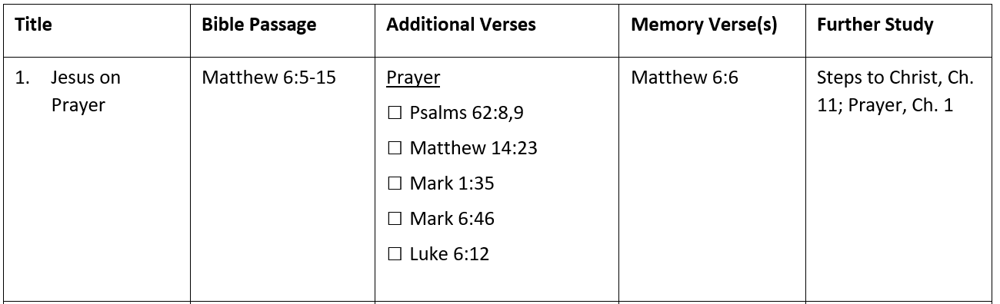
There is a Bible passage, oftentimes a handful of additional Bible verses that highlight an important principle found in the main Bible passage, a memory verse and a chapter from Ellen White that goes along the main Bible passage.
For the preparation we use an empty notebook. (For details look at the document “Personal Preparation”.) One important part of the preparation is writing down the main Bible passage. That may be unusual for some, but it helps so much to study the Bible passage in depth.
We have prepared different modules that correspond to the five stages of discipleship. They don´t have to be studied in a certain sequence. Every group chooses the module that best fits for them. Also remember that the goal of a discipleship group is to start caregroups and Bible studies. Don´t study all the modules. Otherwise, you will be in a discipleship group for years. But that is not the purpose of a discipleship group. Stay as long as needed in order to be able to start a caregroups or give Bible studies.

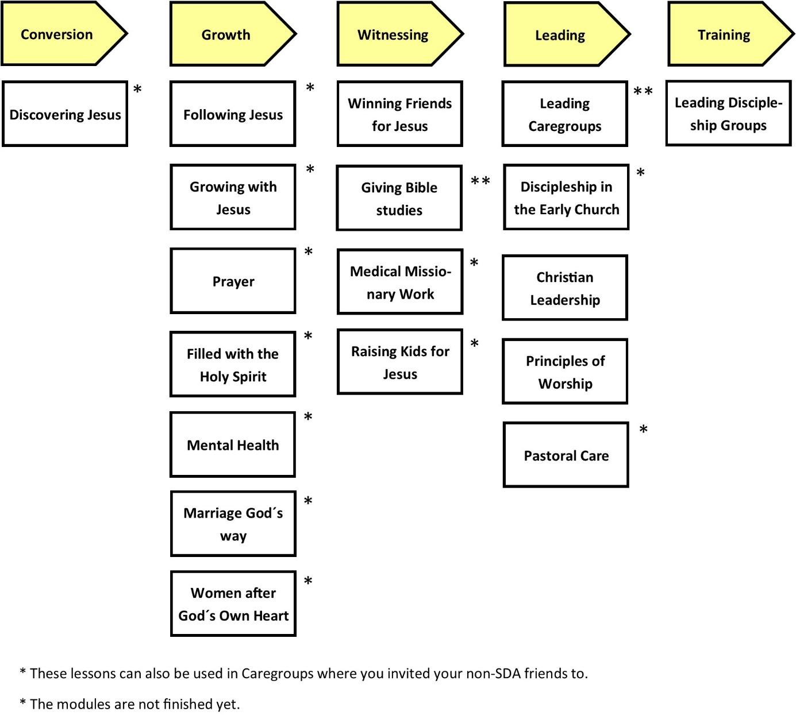

Another important part are the memory verses. At the beginning of the Bible study, take a few minutes to check each other on the memory verses. (See document “Memory Verses)

- What does a Discipleship Group meeting look like?
Following the example of the early church, there are four essential elements in every discipleship group meeting:
Fellowship (20 minutes)
- How are you doing? (What are you thankful for? What are you struggling with? How can we pray for you?)
- Possibly: How can we help?
- Possibly: Read a biblical promise or share an encouraging experience

Bible Study (30 minutes)
- Pray for God´s blessing for the Bible Study
- Check each other on memory verses (in pairs of two)
- Short review of the last topic (What did we learn last time? How did you apply that during the last few days? Who did you share this with?)
- Read the passage together!
- Ask someone to retell the story in his/her own words!
- Discover the Bible passage:
  - What can we learn in this passage about God?
  - What can we learn in this passage about people?
  - What can we learn in this passage about following Jesus?
  - Possibly: What does this passage say about …? (another topic)
  - You may also use the questions you have asked about the passage in your personal preparation!
- Please summarize what the additional bible verses say about the topic!
- Application:
  - How can we obey/apply what we have learned?
  - With whom can we share it?

Ministry (20 minutes)
- Communicate the vision (see appendix in the document “Mission ideas“)
- Accountability: How could you put into practice the challenge from last week (or the challenges from past weeks)?
- New mission challenge (see document “Mission Ideas”)
- Possibly practice the new mission challenge.
- Set a specific ministry goal for next week.

Prayer (20 minutes)
- Pray about what you have learned in the Bible study.
- Pray about the vision of your group.
- Pray about your mission challenge and for the people you want to reach.

Print out the document “Elements of a Discipleship Group Meeting” for every participant as ask them to paste it into their notebooks. This will help them to lead the meeting as well.

- Mission Through Discipleship Groups
It is important to see that small groups exist not only to nurture and establish our church members, as it important as that is. They primarily exist for reaching people with the gospel. We need the inward focus to be filled, encouraged and nurtured. But a group that has only an inward focus will collapse, sooner or later. We also need an outward focus to motivate and equip members for work. There must be a balance between the inward and the outward focus.

This understanding is key: Every small groups exists for people outside of our group. That´s why discipleship groups are places where continual personal evangelism training takes place. Remember, a discipleship group is a small groups of church members that meet to be trained in personal evangelism. The outreach part the part that is most often skipped in small groups. If you are not intentional about the outward focus, you will automatically fall back to the inward only mode. We must continually stress that all small groups exist for people who are not yet in the group! Every small group need this clear understanding: Our small group is not just about us. It exists for people who are not yet in the group.
We will not now focus especially on discipleship groups in which you train your members. If you meet for 90 minutes, you invest about 20 minutes for this part. (It could be more, if needed). So, what do you do in this time? There are five things:
- Vision
- Accountability
- Mission idea & challenge
- Practice
- Goal

Vision
It is important to communicate the vision that God has for our group and our personal lives again and again. We must keep the thought before us that we exist to share the gospel and start new groups (both, discipleship groups and discovery groups). Communicating this vision takes only a very short time. You may read a Bible verse about God´s vision or share an experience. Good Bible verses are:
- 1 Timothy 2:4
- Revelation 7:9,10
- Revelation 14,6
- Isaiah 55:10,11
- Luke 15:7,10
- John 4:35
- Mark 1:14,15
- Matthew 24:14
- Romans 1:16,17
- Acts 1:8

Accountability
You must ask in every meeting how they applied last week´s mission challenge. This is key! This is not about controlling people. It is about loving accountability and support. But you must give them room to share their experience in personal evangelism. If they haven´t done it, encourage them not to give up but do it in the following days. Accountability is important to make things happen.

Mission Idea
In every discipleship group meeting you present or review a short mission idea followed by a specific challenge to be applied until the next meeting. The goal is to have a simple, ongoing personal evangelism training that is put into action. Only as the personal evangelism training leads to action, it can change anything. The mission ideas our found in the document “Mission Ideas”

Practice
Often, we have to practice the mission challenge. As the training leads to competence, practicing leads to confidence. Only, when the members are confident that they can do it, they will actually do it. So, when the mission idea it about sharing your personal testimony, sharing the gospel, telling a Bible story or leading a discovery Bible study, these things must first be practice in the group. Sometimes, you may want to divide our group in pairs of two to do the practice.

Goal
It is important to turn the mission challenge into a specific goal. For example: “I will share my personal testimony with my brother.” If possible, ask them to write down the goal. At any rate, you as leader must write down the goal because next week you want to ask who they were doing. (see accountability)

Sometimes you will need more time for the mission part. In this case, you will have to shorten the fellowship and Bible study or meet longer.

See Mark 3:13-15; John 8:31-32; 13:34-35; 15:5,8
John 15:1-8
John 8:31,32; 17:17
Matthew 7:24-27; John 14:15
Matthew 24:14; Revelation 10:11; 14:6-13
John 13:34-35; 17:20-21; Acts 2:42-47
Mark 1:35; Matthew 6:5-15; Luke 6:12; 11:1-13
Matthew 9:37,38; 10:1
Acts 2:42-47: 5:42; 12:12; 20:20

